RELATIVE ACIDITY & ALKALINITY [pH Scale]

BEHAVIOUR OBJECTIVES
At the end of this lesson, students should be able to;
- Outline 3 uses of pH scale.
- Define pOH, pH and Calculate pH and pOH of given solutions.
- Discuss the applications of pH and pOH in daily life and industries.
- Define indicators and give 5 examples of indicators used in chemistry.
- Demonstrate variation of colour of indicators in various media.

Relative acidity: is a measure of the acidic nature of a substance or solution compared to another substance or a reference point. It is expressed in terms of pH.
Relative alkalinity: is a measure of the alkaline or basic nature of a substance or solution compared to another substance or a reference point. It is expressed in terms of pOH.

pH
The pH of a solution is the negative logarithm of the hydrogen ion concentration to the base 10. It is used to measure the concentration of hydrogen ions in a solution. The full form of pH is the ‘Potential of Hydrogen’.
pH = -log[H⁺]
Ex: If [H⁺] = 10⁻³⁻, calculate the pH of the solution.
pH = -log[H⁺]
pH = -log[10⁻³]
pH = 3

pOH
The pOH of a solution is the negative logarithm of the hydroxide ion concentration to the base 10. It is used to measure the concentration of hydroxide ions in a solution.
pOH = -log[OH⁻]
Ex: If [OH⁻] = 10⁻⁹, calculate the pOH of the solution.
pOH = -log[OH⁻]
pOH = -log[10⁻⁹]
pOH = 9

pH Scale
It is a numbered scale used to measure the acidity or alkalinity of a solution. pH scale ranges from 0 to 14, with 7 being considered neutral, i.e. neither acidic or alkaline. pH values below 7 indicates acidity, while pH values above 7 indicates alkalinity. So, strong acids have low pH value while strong bases have high pH value.

Uses of pH scale
- It is used to determine the acidic or basic nature of the solution.
- It is used to determine hydronium ion concentration present in the solution.
- It is used to find out neutrality of the solution.

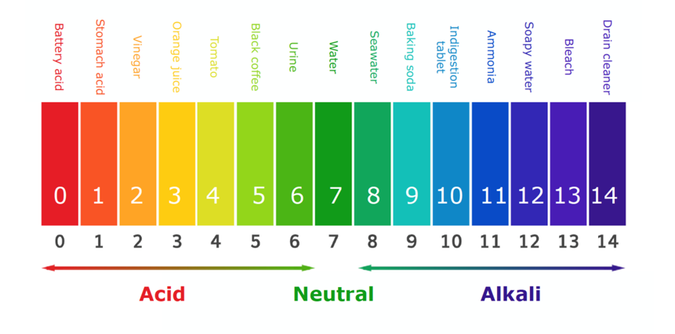
Relationship between pH and pOH
H₂O ⇄ H⁺ + OH⁻
From conductivity measurement,
[H⁺] [OH⁻] = 10⁻¹⁴
pH + pOH = 14
pH = 14 – pOH, pOH = 14 – pH
Ex:
- Find the hydrogen ion and hydroxide ion concentration in
- 0.001 Sodium hydroxide solution
- 0.02M tetraoxosulphate(VI) acid solution

Solution
a. NaOH_{(aq)} ⇄ Na_{(aq)} + OH⁻_{(aq)}
From the equation,
1 moldm⁻³ NaOH ionizes to give 1 moldm⁻³ OH⁻ (monobasic)
0.001 moldm⁻³ NaOH ionizes to give 0.001 moldm⁻³ OH⁻
[OH⁻] = 0.001 moldm⁻³
[H⁺] [OH⁻] = 10⁻¹⁴
(0.001) [H⁺] = 10⁻¹⁴
[H⁺] = $\frac{{10}^{-14}}{0.001}=1.0 × {10}^{-11} mol{dm}^{-3}$
[H⁺]= 1.0 $×$ 10⁻¹¹ moldm⁻³, [OH⁻] = 0.001 moldm⁻³

b. H₂SO_{4(aq)} ⇄ 2H⁺_{(aq)} + SO₄²⁻_{(aq)}
From the equation,
1 moldm⁻³ H₂SO₄ ionizes to give 2 moldm⁻³ H⁺ (dibasic)
0.02 moldm⁻³ H₂SO₄ ionizes to give (2 $×$ 0.02) moldm⁻³ H⁺
[H⁺] = 0.04 moldm⁻³
[H⁺] [OH⁻] = 10⁻¹⁴
(0.04) [OH⁻] = 10⁻¹⁴
[OH⁻] = $\frac{{10}^{-14}}{0.004}=2.5 × {10}^{-12} mol{dm}^{-3}$
[H⁺] = 0.04 moldm⁻³, [OH⁻] = 2.5 $×$ 10⁻¹² moldm⁻³

- What is the concentration of H⁺ ions in mole per dm³ of a solution of pOH 9.602?
pH + pOH = 14
pH = 14 – pOH
pH = 14 – 9.602 = 4.398
pH = -log[H⁺]
4.398 = -log[H⁺]
[H⁺] = 10^{(-4.398)}
[H⁺] = 4.0 $×$ 10⁻⁵ moldm⁻³

Applications of pH
- Agriculture: Farmers use pH measurements to assess the soil's acidity or alkalinity.
- Quality Control: Many manufacturing processes require precise pH control to maintain product quality.
- Swimming Pools: Maintaining the proper pH in swimming pools and spas is necessary to ensure the water is safe and comfortable for swimmers.
- Water Quality Testing: Drinking water, wastewater, and natural bodies of water are tested to ensure they meet appropriate pH standards.
- Healthcare: The pH of body fluids, such as blood and urine, is monitored in clinical settings to diagnose and manage health conditions.

Indicators
Indicators are weak organic acids or bases that show a colour change in solution based on the hydrogen ion, H⁺, concentration in that solution.
Indicators are usually weak acids or bases so they ionize partially in solution. The colour change is based on the degree of its ionization in that solution. Each indicator has its own specific pH range over which it changes colour.

Types of indicators
- Natural Indicators: are indicators found in nature used to detect the acidity or alkalinity of a substance. e.g. litmus paper, turmeric, grape juice, china rose.

- Synthetic indicators: are indicators that are synthesized in the laboratory. E.g. Methyl orange, Phenolphthalein.

Colour Change for some Indicators

Indicator | pH range | Colour | Acidic Medium | Alkaline Medium
Methyl Orange  Litmus  Phenolphthalein | 3.1 – 4.6  5.0 – 8.0  8.3 – 10.0 | Orange  Purple  Pale pink | Red  Red  colourless | Yellow  Blue  Pink

Titration Table

Titration | Example | Rapid change of pH | Indicator
Strong acid  Strong base  Strong acid  Weak base  Weak acid  Strong base  Weak acid  Weak base | Hydrochloric acid  Sodium hydroxide  Hydrochloric acid  Aqueous ammonia  Ethanoic acid  Sodium hydroxide  Ethanoic acid  Aqueous ammonia | 3.5 to 9.5  3.5 to 7.0  7.0 to 9.5  No sharp change | Any indicator  Methyl Orange  Phenolphthalein  No suitable indicator

DRILL QUESTIONS

- A sample of orange juice is found to have a pH of 3.80. what is the concentration of the hydroxide ion in the juice?
- 1.6 $×$10⁻⁴
- 6.3 $×$ 10⁻¹¹
- 6.3 $×$ 10⁻⁴
- 1.6 $×$10⁻¹¹

- What is the pH of 2.50 $×$ 10⁻⁵M solution of Sodium hydroxide?
- 3.6
- 5.0
- 9.4
- 12.0

- The colour of phenolphthalein in alkaline medium?
- Yellow
- Colourless
- Pink
- Orange

- Which of the following is not a natural indicator?
- Litmus paper
- China Rose
- Beetroot
- None of the above

- The colour of litmus in neutral medium is ________?
- Purple
- Yellow
- Orange
- Pink

ANSWER
- B
- C
- C
- D
- A

